MOGADISHU THEN AND NOW

A pictorial tribute to Africa’s most wounded city

## RASNA WARAH, MOHAMUD DIRIOS & ISMAIL OSMAN

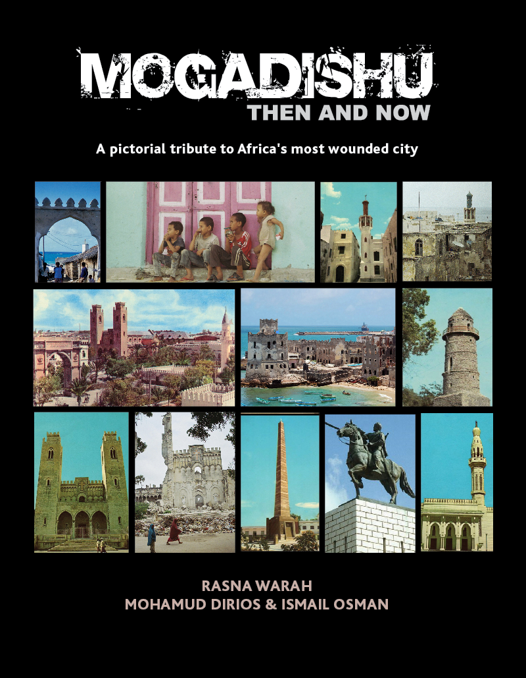

M

ogadishu was once one of the prettiest and most cosmopolitan cities in Africa. The city has a long history that dates back to the 10th century when Arab and Persian traders began settling there. For centuries Mogadishu was a traditional centre for Islam and an important hub for trade with communities along the Indian Ocean coastline. However, since the beginning of the civil war in the early 1990s, Somalia’s capital city has gained the reputation of being the most dangerous and violent city in the world.

***Mogadishu Then and Now*** is an attempt to redeem the city’s damaged reputation and restore its lost glory in the public imagination. The book showcases Mogadishu in all its splendour prior to the civil war and contrasts this with the devastation and destruction that has characterised the city for more than two decades. It is hoped that the book will encourage present and future generations to learn about Mogadishu’s rich cultural heritage and inform future urban planning initiatives, especially now that Somalis and the international community are strengthening their efforts to restore peace and stability in Somalia. It should be of particular interest to historians, urban planners, architects and anthropologists.

ISBN: 978-1-47722-903-3

*“****With so much destroyed in the city, the rescued images in this book are an invaluable record. They offer proof that Mogadishu was once a peaceful city. Although its old beauty is gone forever, it is possible that the city once known as the ‘The White Pearl of the Indian Ocean’ will have another day in the sun.”***

*–* Mary Harper, author of *Getting Somalia Wrong?*

**Now available from these retail outlets:**

[**www.amazon.com**](http://www.amazon.com)

[**www.authorhouse.com**](http://www.authorhouse.com)

**Bookstop, Yaya Centre, Nairobi**

**Can also be ordered through Barnes and Noble (USA) and WH Smith (UK)**

**For more information, contact Rasna Warah:**

[**rasna.warah@gmail.com**](mailto:rasna.warah@gmail.com)